GuitarWorld Database
CA2 – Introduction to Data Analytics
Dominic Callan
Student number: 17164605

Table of Contents

Table of Contents 2
Introduction 3
Q1 - Show Transactions for ANY given week in your business 3
Q2 – Create a Trigger that stores stock levels once a sale has taken place 4
Q3 – Create a view of stock (grouped by supplier) purchased by you. 6
Q4 - Display total stock sold to the general public (by supplier). (Group-By with RollUp) 7
Q5 – Detail and total all transactions for the month-to-date. (A Group By with RollUp) 8
Q6 – Detail and total all revenue for the year-to-date. (A Group By with Roll-Up) 8
Q7 – Detail and total transactions broken down on a monthly basis for 1 year (a group-by with Rollup) 9
Q8 – Display the Growth in sales / services for your business, from the first month of opening until end of year. 10

Introduction

This database is for a retail store that sells guitars. The store opened in March 2018, this database contains sales info from March 2018 to December 2018.
The database has four tables:
- CUSTOMERS
- ORDERS
- PRODUCTS
- SUPPLIER

Q1 - Show Transactions for ANY given week in your business

I have chosen the first week in March, this was the first week that the business was open, and it was a busy week. Here is the SQL code:

SELECT * FROM ORDERS
WHERE OrderDate BETWEEN '2018-03-01' AND '2018-03-08'
ORDER BY OrderDate ASC;

Here is the output from running this code:
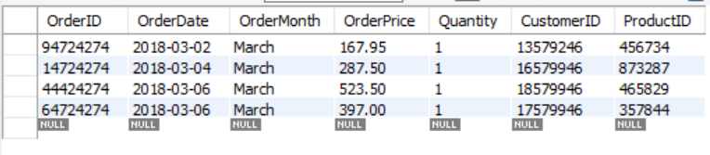

As we can see, there were a total of four orders in the first week in March.

Graphical representation 1 (for Q1):

Q2 – Create a Trigger that stores stock levels once a sale has taken place

For this question, I have created a Trigger that reduces the StockLevel quantity from my PRODUCTS table when an order is inserted into my ORDERS table. I will demonstrate an example of this Trigger working.
Firstly, here is the code to create a view of the existing stock levels by supplier:
SELECT * FROM Stock_by_supplier;

And here is the output:

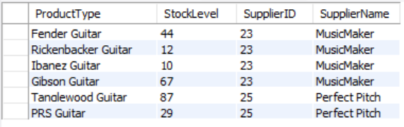

Note that there are currently 44 Fender Guitars in stock, a reduction of one.

Next, we can run the code for our Trigger:
CREATE TRIGGER UpdateStock
AFTER INSERT ON ORDERS
FOR EACH ROW

UPDATE PRODUCT
SET StockLevel = StockLevel - New.Quantity
WHERE ProductID = NEW.ProductID;

Next, we insert a new order for one Fender Guitar to test our Trigger:
INSERT INTO ORDERS(OrderID,OrderDate, OrderMonth, OrderPrice,Quantity,CustomerID,ProductID)
VALUES (454533545, '2018-13-11', 'December', 167.95, 1, 17579946, 456734);

To test if this Trigger has worked correctly, we can run Stocklevel view code again to get another view of the existing stock levels to see if the level of Fender Guitars has reduced by one:

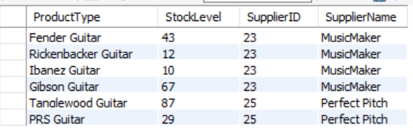

We now have one less Fender Guitar in stock (43 instead of 44), proving that our Trigger is working.

Q3 – Create a view of stock (grouped by supplier) purchased by you.

Here is the code:
CREATE OR REPLACE VIEW Stock_by_supplier AS
SELECT PRODUCT.ProductType, PRODUCT.StockLevel, PRODUCT.SupplierID, SUPPLIER.SupplierName
FROM PRODUCT, SUPPLIERstock_by_supplierstock_by_supplier
WHERE PRODUCT.SupplierID = SUPPLIER.SupplierID
ORDER BY SUPPLIER.SupplierName;

SELECT * FROM Stock_by_supplier;

And here is our output:
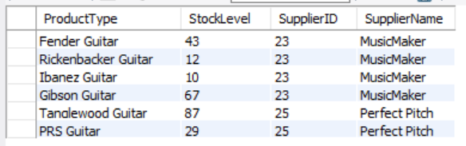

Q4 - Display total stock sold to the general public (by supplier). (Group-By with RollUp)

We have two suppliers that supply stock to our store.
Here is the code:
SELECT COALESCE(SUPPLIER.SupplierName, 'TOTAL') AS SupplierName, PRODUCT.SupplierID, SUM(ORDERS.OrderPrice) AS 'Total Amount'
FROM ((ORDERS
INNER JOIN PRODUCT ON ORDERS.ProductID = PRODUCT.ProductID)
INNER JOIN SUPPLIER ON PRODUCT.SupplierID = SUPPLIER.SupplierID)
GROUP BY SupplierName WITH ROLLUP;

Here is the output:
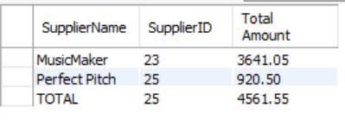
Graphical representation 2 (for Q3):

Q5 – Detail and total all transactions for the month-to-date. (A Group By with RollUp)

Please note I am running this query in the month of April, you will get a different output running it in a different month.
SELECT coalesce (OrderID, 'GrandTotal') AS OrderID,
SUM(OrderPrice) as TotalOrderPrice, OrderDate
FROM ORDERS
WHERE MONTH(OrderDate) = MONTH(CURRENT_DATE())
GROUP BY OrderID WITH ROLLUP;

Output:

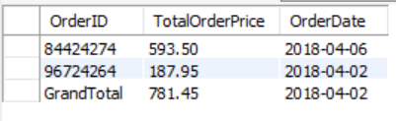

Q6 – Detail and total all revenue for the year-to-date. (A Group By with Roll-Up)

This shop opened in March 2018, total revenue for the year to date will be a total from March 1st, 2018 up to the current date.
SELECT * FROM (
SELECT Coalesce(PRODUCT.ProductType, 'Grand Total') AS ProductType, ORDERS.OrderDate, ORDERS.ProductID, SUM(ORDERS.OrderPrice) as TotalOrderPrice
FROM (ORDERS INNER JOIN PRODUCT ON ORDERS.ProductID = PRODUCT.ProductID)
WHERE OrderDate BETWEEN '2018-01-01' AND DATE(CURRENT_DATE)
GROUP BY PRODUCT.ProductType with ROLLUP
)
AS T;

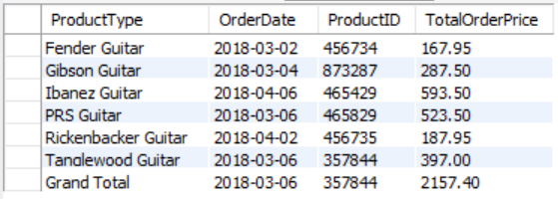

Q7 – Detail and total transactions broken down on a monthly basis for 1 year (a group-by with Rollup)

Shop opened in March 2018, figures for March to December.
SELECT * FROM (
SELECT Coalesce(MONTHNAME(ORDERS.OrderDate), 'Grand Total') AS OrderDate, SUM(ORDERS.OrderPrice) as TotalOrderPrice
FROM ORDERS
WHERE OrderDate BETWEEN '2018-01-01' AND '2018-12-31'
GROUP BY MONTH(ORDERS.OrderDate) with ROLLUP)
AS T;

Output:
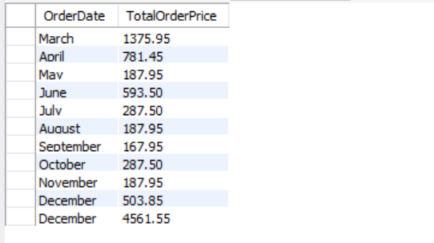

Q8 – Display the Growth in sales / services for your business, from the first month of opening until end of year.

SELECT Coalesce(OrderDate, 'Grand Total') AS OrderDate
,TotalOrderPrice
FROM (
SELECT MONTHNAME(ORDERS.OrderDate) as OrderDate,
SUM(ORDERS.OrderPrice) as TotalOrderPrice,
MONTH(ORDERS.OrderDate) as MonthNum
FROM ORDERS
WHERE OrderDate BETWEEN '2018-01-01' AND '2018-12-31'
GROUP BY MONTHNAME(ORDERS.OrderDate),
MONTH(ORDERS.OrderDate) with ROLLUP)
AS T
ORDER BY COALESCE(MonthNum,13);

SET @Last_Month_TotalOrderPrice := 0;

SELECT OrderDate, TotalOrderPrice, MonthlyPercentChange
FROM (
SELECT OrderDate
,TotalOrderPrice
,CASE WHEN @Last_Month_TotalOrderPrice = 0
THEN NULL
ELSE (TotalOrderPrice - @Last_Month_TotalOrderPrice) * 100.00 / @Last_Month_TotalOrderPrice
END as MonthlyPercentChange
,@Last_Month_TotalOrderPrice := TotalOrderPrice
,MonthNum
FROM (
SELECT MONTHNAME(ORDERS.OrderDate) as OrderDate,
SUM(ORDERS.OrderPrice) as TotalOrderPrice,
MONTH(ORDERS.OrderDate) as MonthNum
FROM ORDERS
WHERE OrderDate BETWEEN '2018-01-01' AND '2018-12-31'
GROUP BY MONTHNAME(ORDERS.OrderDate),
MONTH(ORDERS.OrderDate)
) AS T
ORDER BY MonthNum) as SQ
ORDER BY MonthNum;

* (2018, Fozz, RD)

Here is the output:

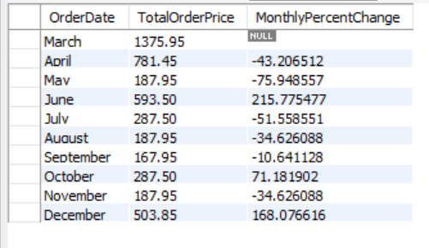

Graphical representation 3 (for Q8):

References:
*Fozz, R.D.. “Stack Exchange Network.” dba.stackexchange.com. https://dba.stackexchange.com/questions/204123/calculating-percentage-growth-month-by-month (accessed April 21, 2018).

